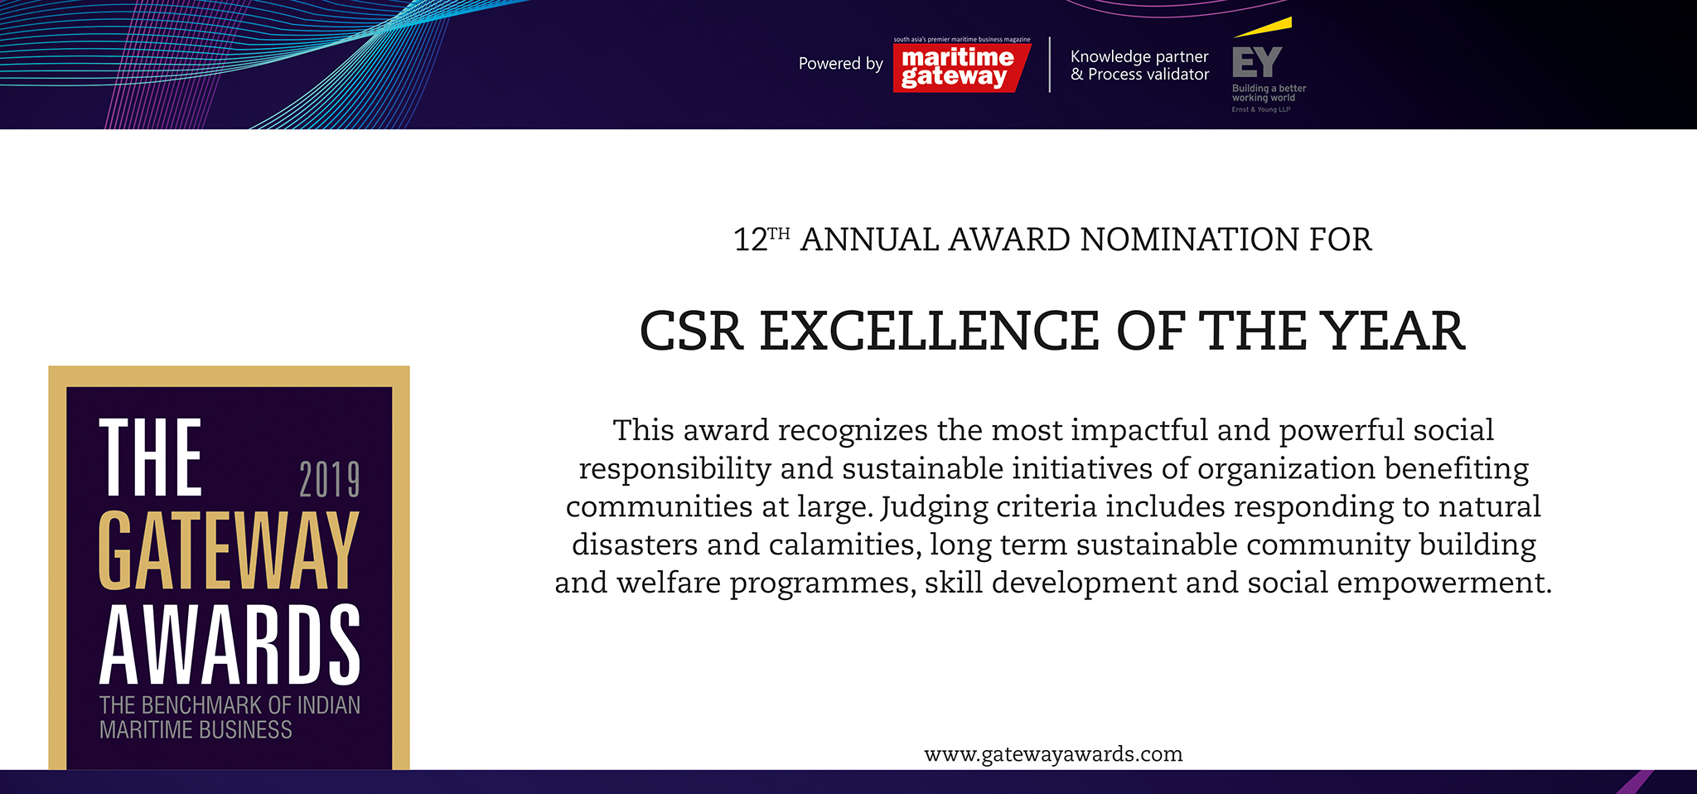

Please fill your responses and mail it to the address mentioned at the end of the Questionnaire

Note: All information and data should be provided for the FY 2018-19. In case, if you are unable to provide FY 2018-19 data, CY2018 information can be sent with a reason for not providing data for FY 2018-19.

Contact information:
Name of the Organization

Contact Person

Designation

Contact no.

Official Email ID

Address

 | Parameters | Units | Inputs
 | Community welfare activities. | • Rebuilding the deprived  societies  • Community involvement  • Local Social-economic  Development  • Word limit ~ 200 words
 | Disaster Relief | • Humanitarian aid  • Infrastructure rebuilding  • Environmental clean-up &  rehabilitation  • Word limit ~ 200 words

Please use below contact for sending filled-in form and also for any queries.

Rakesh Oruganti | Cell: +91 99483 34568;E mail ID: rakesh.oruganti@gatewaymedia.in

1

